Philosophy tasks summary

**EXERCISES PHIL 1**

**WEEK 1**

**1.What is the conclusion in this argument?**

*There can’t be weapons of mass destruction in Iraq.  If there were, then the military forces would have found them by now, or some radicalized group of insurgents would have used them.  But the military forces haven’t found them and no insurgent groups have used any.*

ANSWER:   
There can’t be weapons of mass destruction in Iraq.”  is the conclusion.

**2. Individuate explicit and implicit premises in this argument**

"I think she's not home.  If she drove home, then her car would be in the driveway.  And it's raining, so she didn't walk home,"

ANSWER:

"If she drove home, then her car would be in the driveway," is an explicit premise.  "Her car is not in the driveway," is an implicit premise.

**3. Individuate the implicit premise in this argument**   
*"Positive thinking cannot help you win the lottery.  If it could, then lots of people would win."*

ANSWER:  
"Lots of people do not win."  is an implicit premise.

Notice that when we add it, the argument becomes valid and much clearer:

1.  If positive thinking could help you win the lottery, then lots of people would win the lottery.

2.  Lots of people do not win the lottery.

_________________________________

3.  Therefore, positive thinking cannot help you win the lottery.

**4. Reconstruct this argument***The starter must be broken.  If the car won't start, then it's either the starter, the alternator, or the battery that's the problem.  It won't start.  And we've ruled out the alternator since we just put a new one in, and it can't be the battery because it's fully charged.*

ANSWER: The conclusion is "The starter must be broken."

One explicit premise is this conditional: "If the car won't start, then it's either the starter, the alternator, or the battery that's the problem."

Another explicit premise is "The car won't start."  (Notice that I've changed the language to match the previous sentence exactly.)

So, we can put together this reconstruction:

1.  If the car won't start, then either the starter is broken, the alternator is broken, or the battery is dead. (EP) (notice the editing)

2.  The car won't start. (EP)

3.  The alternator is not broken.  (IP) (notice the editing to match language in 1)

4.  The battery is not dead.  (IP)     (notice the editing to match the language in 1.

____________________________________________

5.  Therefore, the starter is broken.  (1,2,3,4)

**5. Reconstruct this argument***I’m pretty sure that if you get caught base jumping in a national park, it is a misdemeanor offense.  And if you get convicted of a misdemeanor offense, it's a parole violation.  I heard that while he was on parole, Fernando went base jumping in Yosemite and got caught.  And if Fernando violates his parole one more time, immigration services is going to deport him. So I think he is going to get deported.  That's too bad.  He was a great guy.*

ANSWER:  
The conclusion is "Fernando got deported."

The sentence:   I’m pretty sure that if you get caught base jumping in a national park, it is a misdemeanor offense. gets translated to this premise.

Notice that the language has been adjusted to match the other premises and words have been eliminated:

"If you get caught base jumping in a national park, then you get convicted of a misdemeanor offense."  And if you get convicted of a misdemeanor offense, it's a parole violation, becomes:  "If you get convicted of a misdemeanor offense, then you get a parole violation."And this premise is also explicit:  "If Fernando gets a parole violation, then immigration services is going to deport him."It is not stated, but it is clearly implied that "Yosemite is a national park."

1.  If a person gets caught base jumping in a national park, then that person is convicted of a misdemeanor offense. [EP]

2.  If a person gets convicted of a misdemeanor offense, then that person gets a parole violation.  [EP]

3.  If Fernando gets a parole violation, then immigration services is going to deport him. [EP]

4.  Yosemite is a national park.  [IP]  
5.  Fernando got caught base jumping in Yosemite.  [EP]  
6.  Fernando got caught base jumping in a national park.  [4,5]  
7.  Fernando got convicted of a misdemeanor offense.  [1, 6]  
8.  Fernando got a parole violation.  [2, 7]  
______________________________________  
9.  Therefore, Fernando is going to get deported.  [3,8

Notice that the implicit premise has been brought out, and all of the intermediate inferences have been stated in order to validly get to the conclusion.

**6. Evaluate the following argument**

1. If Idaho is larger than California, then it is larger than Alaska.
2. Idaho is larger than California.  
   ----------------------
3. Therefore, Idaho is larger than Alaska.

ANSWER:  
Evaluated in terms of its form, this is a good argument.  But it is nevertheless a bad argument.  After all, each of the sentences is false.  Sentences (2) and (3) are clearly false, but so too is (1), since if Idaho were larger than California, it could still be smaller than Alaska, given that Alaska is bigger than California.  What this demonstrates is that when it comes to argument quality, form isn't everything.  Content matters, and here the content is in bad shape.

The content of an argument is what the argument is *about*, and this is based on what the sentences that constitute the argument are about.  The primary measure of content quality is truth value.  If any of the sentences are false, then the argument will be weak.  If the sentences are true, then the argument will typically be strong, so long as it has good form.

**7. Evaluate the following argument**

1. Idaho is south of Canada.
2. Nevada is south of Idaho.  
   ----------------------
3. Therefore, Texas is south of Oklahoma.

ANSWER:  
All of the sentences in (III) are true, but it is still a bad argument. The truth values of (1) and (2) don't force (3) to be true because (1) and (2) have nothing to do with (3).  Thus, the reasons and conclusion should have content that is related.  This is often guaranteed by the form of the argument---in the case of (III), the argument has bad form, and this undermines the connection between the reasons and conclusion.

**Seminar Week 2**

**PHIL 1**

**Exercises**

Circle the signals and highlight the conclusions in the following passages

1. Our whole class has to stay after school for an hour. So I’m going to need a ride home, because the bus leaves right after school.

2. Humans and many higher animals have similar neurophysiological structures. Humans and animals exhibit many of the same behavioral responses to stimuli. It is reasonable to suppose that animals feel pain and pleasure as we humans do.

3. “And he went from there, and entered their synagogue. And behold, there was a man with a withered hand. And they asked him, ‘is it lawful to heal on the Sabbath?’ so that they might accuse him. He said to them, ‘what man of you, if he has one sheep, and it falls into a pit on the Sabbath, will not lay hold of it and lift it out? Of how much more value is a man than a sheep? So it is lawful to do good on the

Sabbath’” (Matthew 12:9–12).

4. Two out of three people interviewed preferred Zest to another soap. Therefore Zest is the best soap available.

5. In the next century, more and more people will turn to solar energy to heat their homes because the price of gas and oil will become prohibitive for most consumers and the price of installing solar panels will decline

**Completing an Argument**

Complete the following arguments, using all and only the words from the following list:

benevolence, depends, develop, effective, fails, homicide, never, unless, virtues, why

1. God has all the virtues. And ____ benevolence ____ is one of the __ virtues ___. So God must have

benevolence.

2. Abortion involves the taking of a human life. That’s __ homicide ____, and you would ____ never _

encourage homicide, would you? So abortion should not ever be encouraged.

3. Prisons do not rehabilitate anyone. No criminal penalty that ___ fails _______ to rehabilitate can be

___ effective _. That’s _______ why ____ prisons are ineffective as punishment for criminal behavior.

4. The United States must become energy independent. unless ______ we develop widespread collection and use of solar energy, our survival __ depends ______ on increasingly scarce petrochemical energy.

That’s why the United States should _____ develop _____ widespread collection and use of solar energy.

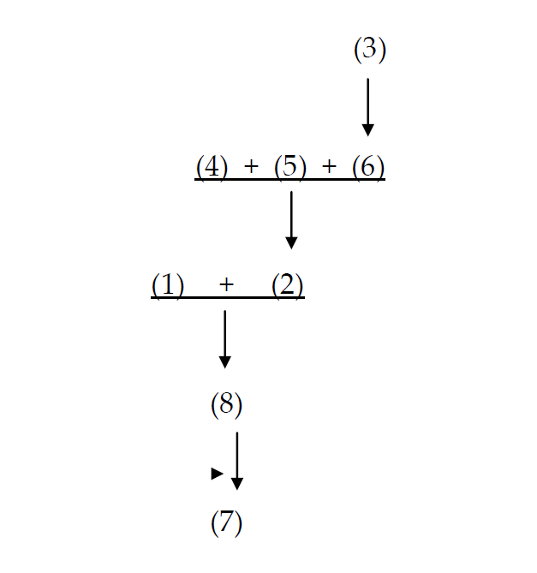**Diagramming**

(1)There are profound mysteries in the universe, and only the investigation of such a mystery is truly worthy of a lifetime of scientific investigation*. (2) Take the profoundly mysterious intelligence of Thermos bottles: clearly we are here in the presence of a life-form the nature of whose cognitive capacities eludes us. (3) A Thermos keeps hot things hot and cold things cold. But how does it know? (4) It has no discernable sense organs. (5) It has no organic parts. (6) Yet the Thermos reliably differentiates its responses, which is a sure sign of intelligence. (7) I therefore propose to dedicate the remainder of my scientific career to the problem of communicating with this novel life form, as (8) this is a problem worthy of such research.

*It is also acceptable to split the first sentence in two (1) There are profound mysteries in the universe, and (2) only the investigation of such a mystery is truly worthy of a lifetime of scientific investigation. The diagram will change accordingly.

EXPLANATION

The inference indicator ‘as’ between (7) and (8) tells us that the arguer is offering (8) as a reason for (7). (8) is based upon (1) + (2). This is because (1) tells us that all profound mysteries are worth spending one’s life scientifically investigating and (2) tells us that that the intelligence of Thermos bottles is a profound mystery. So it is worth dedicating one’s life to the investigation of this mystery. The mystery is how a Thermos knows how to keeps hot things hot and cold things cold. Since it knows this, it reliably differentiates its responses. So apparently, the arguer is offering (3) as a reason for (6). But to add to the mystery of how it knows this as a reason for (2), the arguer adds (4) and (5) to (6). Given that the Thermos is a life-form, the mystery deepens if we say that it has no sense organs that we can discern and has no organic parts.

**Logical Structure**

Identify the logical structure of each of the following examples and write it down without looking at the slides from the lecture

"If it is a car, then it has wheels. It is a car. Therefore, it has wheels."

ANSWER: (Modus Ponens)

"If it is a car, then it has wheels. It does not have wheels. Therefore, it is not a car." ANSWER: (Modus Tollens)

"If it is a car, then it has wheels. It has wheels. Therefore, it is a car."

ANSWER: (Affirming the Consequent.)

"If it is a car, then it has wheels. It is not a car. Therefore, it does not have wheels." ANSWER: (Denying the Antecedent)

**Here are less sensible examples. Can you determine whether these are examples of Modus Ponens, Modus Tollens, Disjunctive Syllogism or one of the incorrect constructions (affirming the consequent, denying the antecedent)? Language is irrelevant, focus on the structure of the sentence. Again once you identified the logical structure at stake, try to write down its formula without looking at the slides.**

"If Xyrplex is 9, Guffaw is 1. Guffaw is 2. Therefore, Xyrplex is not 9." (ANSWER: Modus Tollens)

"If Nagini is a Snake, Snape is a goner. Nagini is a snake. Therefore, Snape is a goner." (ANSWER: Modus Ponens)

‘Either the Sun orbits the Earth, or the Earth orbits the Sun. The Sun does not orbit the Earth. Therefore, the Earth orbits the Sun.  
ANSWER: disjunctive syllogisms

"If Blurts are Flurts, Green is Grue. Green is Grue. Therefore, Blurts are Flurts." (ANSWER:  - Affirming the Consequent)

"If Sagan has hair, Tyson is awesome. Sagan has hair. Therefore, Tyson is awesome." (ANSWER: Modus Ponens)

"If Fordham brings a ram, Peruna will kick. Fordham did not bring a ram. Therefore, Peruna did not kick." (ANSWER: Denying the Antecendent

‘The cake has either chocolate or vanilla frosting. The cake does not have vanilla frosting. Therefore, the cake has chocolate frosting’.  
ANSWER: disjunctive syllogisms

**DIAGRAM THE FOLLOWING PASSAGES**

1. 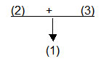All natural disasters are comforting because (2) they reaffirm our impotence. (3) At times it is strangely sedative to know the extent of your own powerlessness.

1. 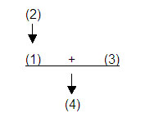Democratic laws generally tend to promote the welfare of the greatest possible number, because (2) they emanate from the majority of the citizens, who are subject to error, but who cannot have an interest opposed to their own advantage. (3) The laws of an aristocracy tend, on the contrary, to concentrate wealth and power in the hands of a minority. It may therefore be asserted that (4) a democracy is more useful to humanity as a whole than an aristocracy.

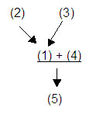The claim that (1) men don't know how to search for anything is supported by two reasons. (2) They always ask where things are even if they're supposed to know where these things are. (3) And they consistently forget about the most obvious places to look. (4) Not being able to search properly makes one rather silly. All in all, (5) men are just silly creatures.

1. 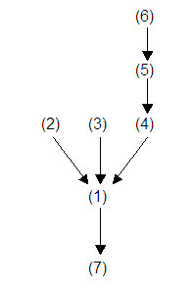Starting your own business is not as easy as it seems. (2) First of all you have to have enough capital or you'll be faced with huge loans. Then, (3) finding a niche in the market where you can survive is really difficult. And (4) you'll never have a day off again as (5) you'll always be working since (6) it is your own business. (7) So think again before you decide to go for it.

**1.** Consider the following argument:

If you buy the jumbo popcorn, then you will need a large drink. You bought the jumbo popcorn. You will need a large drink.

This argument is valid.

**modus ponens**

**2.**Consider the following argument:

If you get the bon bons, you won’t need popcorn. Ruslan needed popcorn. So, he did not get the bon bons.

This argument is valid

**modus tollens**

**3.** Consider the following argument:

Anyone who plays the piano well must have done a lot of practice. Yuja has done a lot of practice. Therefore, she plays the piano well.

This argument is INvalid.

`**False (syllogism, affirming the consequent; it’s not a valid argument)**

**LAB SESSIONS – PHIL 1 – WEEK 4**

1. **Answer the Following open question to the best of your possibility. Limit ½ page A4**
2. What is a categorical proposition? What is a class?
3. How many categorical propositions are out there and what are their characteristics in terms of inclusion/exclusion, universality/particularity, affirmative/negative? Explain the details
4. Now explain the details with a table, don’t just copy the slides.

**B. Which terms are distributed and which are undistributed, explain why**

*1.All senators are citizens*

In the A proposition (e.g., “All senators are citizens”): In this proposition,

“senators” is distributed, but “citizens” is not. In A propositions (universal affirmatives) the subject term is distributed, but the predicate term is undistributed.

*2.No athletes are vegetarians*

In the E proposition (e.g., “No athletes are vegetarians”): The subject

term, “athletes,” is distributed, because the whole class of athletes is said to be

excluded from the class of vegetarians. However, in asserting that the whole

class of athletes is excluded from the class of vegetarians, it is also asserted that

the whole class of vegetarians is excluded from the class of athletes. Of each and

every vegetarian, the proposition says that he or she is not an athlete. Unlike an

A proposition, therefore, an E proposition refers to all members of the class designated by its predicate term, and therefore also distributes its predicate term. E

propositions (universal negatives) distribute both their subject and their predicate

terms.

*3. Some soldiers are cowards*

In the I proposition (e.g., “Some soldiers are cowards”): No assertion is

made about all soldiers in this proposition, and no assertion is made about all

cowards either. It says nothing about each and every soldier, and nothing about

each and every coward. Neither class is wholly included, or wholly excluded,

from the other. In I propositions (particular affirmatives) both subject and predicate

terms are undistributed.

*4.Some horses are not thoroughbreds*

In the O proposition (e.g., “Some horses are not thoroughbreds”):  
Nothing is said about all horses. The proposition refers to some members of the class designated by the subject term: it says, of this part of the class of horses, that it is excluded from the class of all thoroughbreds. But they are excluded from the *whole* of the latter class. Given the particular horses referred to, the proposition says that each and every member of the class of thoroughbreds is *not* one of those particular horses. When something is said to be excluded from a class, the whole of the class is referred to, just as, when a person is excluded from a country, all parts of that country are forbidden to that person. In O propositions (particular negatives) the subject term is not distributed, but the predicate term is distributed. We thus see that universal propositions, both affirmative and negative, distribute their subject terms, whereas particular propositions, whether affirmative or negative, do not distribute their subject terms. Thus the *quantity* of any standard-form categorical proposition determines whether its *subject* term is distributed or undistributed. We likewise see that affirmative propositions, whether universal or particular, do not distribute their predicate terms, whereas negative propositions, both universal and particular, do distribute their predicate terms. Thus the *quality* of a standard-form categorical proposition determines whether its *predicate* term is distributed or undistributed.

**C. Individuate quality, quantity and whether subject and predicate terms are distributed**

*Some presidential candidates will be sadly disappointed people.*Quality: affirmative; quantity: particular; subject and predicate terms bothundistributed.

*No leader of the feminist movement is a major business executive*Quality: negative; quantity: universal; subject and predicate terms bothdistributed.

*All new labor-saving devices are major threats to the trade union*

*movement.*Quality: affirmative; quantity: universal; subject term distributed, predicateTerm undistributed.

**D. Identify subject and predicate terms in, and name the form of, each of the following propositions:**

*Some historians are extremely gifted writers whose works read like*

*first-rate novels.*

*S* _ historians;

*P* _ extremely gifted writers whose works read like first-rate novels.

Form: Particular affirmative.

*Some members of families that are rich and famous are not persons of*

*either wealth or distinction.*

*S* _ members of families that are rich and famous;

*P* _ persons of either wealth or distinction.

Form: Particular negative.

*No people who have not themselves done creative work in the arts are*

*responsible critics on whose judgment we can rely*

*S* _ people who have not themselves done creative work in the arts;

*P* _ responsible critics on whose judgment we can rely.

Form: Universal negative.

**E. Which terms are distributed?**

1. He who hesitates is lost.  
2. Only men play professional football.  
3. None but citizens may vote.  
4. Only students can eat in Seacobeck.  
5. You can’t run for President if you are not at least 35 years old.  
6. Whoever runs for President is ambitious.  
7. Stephen Carter’s novels offer an interesting portrait of the black bourgeoisie.  
8. Antique dealers can’t run for mayor.  
9. Emoticons annoy everyone.  
10. A rolling stone gathers no moss.  
11. The skies are not cloudy all day.

**ANSWERS:**1. He who hesitates is lost.  
**All hesitators are losers.   subject**

2. Only men play professional football.  
**All people who play professional football are men.  subject**

3. None but citizens may vote.  
**All people who can vote are citizens.  subject**

4. Only students can eat in Seacobeck.  
**All people who can eat in Seacobeck are students.  subject**

5. You can’t run for President if you are not at least 35 years old.  
**All people who can run for President are people who are at least 35.   Subject  
No person younger than 35 can run for President… both**

6. Whoever runs for President is ambitious.  
**All people who run for President are ambitious people.   subject**

7. Stephen Carter’s novels offer an interesting portrait of the black bourgeoisie.  
**All novels by Stephen Carter are novels that offer an interesting portrait of the black bourgeoisie.   subject**

8. Antique dealers can’t run for mayor.  
**No antique dealers are people who can run for mayor .   both**

9. Emoticons annoy everyone.  
**No person is a person who likes emoticons.   Both**  
**All people are people who are annoyed by emoticons.  subject**

10. A rolling stone gathers no moss.  
**No rolling stone is a moss-gatherer.  both**

11. The skies are not cloudy all day.  
**No days are days when the skies are cloudy?    both**  
**Some days are days when the skies are partly cloudy?    Neither**

**F. Rewrite these as standard form categorical propositions:**

1. Whoever has an allergic reaction has a weakened immune system.

2. Lunar eclipses don’t occur unless the moon is full.

3. From time to time there are concerts at Hurcamp Park.

4. If a pregnant woman drinks alcohol, she risks giving birth to a deformed child.

5. At the end of “The Daily Show,” John Stewart always checks in with his good friend Stephen Colbert.

6. Guests on “The Colbert Report” don’t always seem to be clear on the satirical nature of the show.

7. Snow days are great.

8. It’s wrong to depart from the syllabus.

9. Not all the exercises make a lot of sense.

10. The exercises that make sense are easiest to do.

**ANSWERS:**

1. All people who have allergic reactions are people who have weakened immune systems.

2. All times lunar eclipses occur when the moon is full.

3. Some times are times there are concerts at Hurkcamp Park.

4. All pregnant women are people who risk giving birth to a deformed child if they drink alcohol.

or

All pregnant women who drink alcohol are people who risk giving birth to a deformed child.

5. All times that the Daily Show ends are times that Jon Stewart checks in with his good friend Stephen Colbert.

6.Some guests on “The Colbert Report” are not people who seem to be clear on the satirical nature of the show.

7. All snow days are great days.

8. All departures from syllabi are wrongs.

9. Some exercises are not exercises that make a lot of sense.

10. All exercises that make sense are exercises that are easiest to do.

**LAB SESSIONS – PHIL 1 – WEEK 5**

**EXERCISES**

1. **Answer the Following open question to the best of your possibility. Limit ½ page A4**
2. What is the existential import and why is it important?
3. Describe the two interpretation of the existential import in detail (Aristotle vs Boole) and try to reflect on their epistemological repercussions for science
4. Which interpretation of the existential import is currently accepted? And why?

Answer 3: Modern logic rejects existential import for a number of reasons. The most significant for our purposes have to do with the nature of universal claims and our understanding of what it means to say of a proposition that it is false. Starting with the latter, ask yourself what would have to be the case about the world for you to claim that an A type proposition is false. Consider the claim "All swans are

white". In order for that claim to be false, we need to know that there is at least one non-white swan. Imagine how you might argue with someone who insists that it is true that "A'' swans are white". You would produce as evidence for the falsity of the claim the existence of a non-white swan. "No," you might argue, "not all swans are white, for here is a swan that is brown." But now suppose for a minute that there were no swans at all. What sort of evidence could you produce, in the total absence of any swans, against the claim that all swans are white? Obviously, you couldn't produce a non-white one because there aren't any swans at all. In the absence of any evidence for a falsifying instance to the universal claim, you should accept the claim. But now extend that reasoning to universal claims about empty classes and non-existent objects. Universal claims about empty sets are all true, because there are no falsifying instances.

1. Determine whether the following inference is valid on the modern interpretation of the square of opposition; if the inference is valid, explain why; and if the inference is undetermined, explain why.
   * If the A-proposition is true, the E-proposition is_______. undetermined.
2. Determine whether or not the following inference is valid on the modern interpretation of the square of opposition; if the inference is valid, explain why; and if the inference is undetermined, explain why.
   * If the O-proposition is false, the A-proposition is_______.

ANSWER: True. This inference is valid. A- and O-propositions are contradictories. They cannot be simultaneously true or simultaneously false. Hence, if one is true, the other must be false, and vice-versa. Here are some examples:

All stringed instruments are guitars. (False)

Some stringed instruments are not guitars. (True)

Some Blue Jays are not birds. (False)

All Blue Jays are birds. (True)

* 1. **Explain the point or points at which, in each argument, the mistaken existential assumption is made**

1. No mathematician is one who has squared the circle.

*therefore*, (2) No one who has squared the circle is a mathematician; *therefore*, (3) All who have squared the circle are nonmathematicians; *therefore*, (4) Some nonmathematician is one who has squared the circle.

**ANSWER**: Step (3) to step (4) is invalid. The inference at this point is conversion bylimitation (that is, from “All *S* is *P*” to “Some *P* is *S*”), which was acceptable in the traditional interpretation but is invalid in the Boolean interpretation. This step relies on an inference from a universal proposition to a particular proposition,

but for Boole the classes in a universal proposition cannot be assumed to have members, whereas the classes in a particular proposition do have members. Thus the invalid passage from (3) to (4) permits the inference that the predicate class in

1. is not empty, and therefore that there *is* someone who has squared the circle In inferring (4) from (3), one commits the existential fallacy.

(1) It is false that: Some mermaids are members of college

sororities; *therefore* (2) It is true that: Some mermaids are not members of college sororities. (From which it follows that there exists at least

one mermaid.)

**ANSWER**: Step (1) to step (2) is invalid: (1) asserts the falsehood of an **I** proposition;

1. asserts the truth of its corresponding **O** proposition. Because both **I** and **O** propositions do have existential import, both *can* be false (in the Boolean interpretation) if the subject class is empty. The subject class *is* empty in this case, because there are no mermaids. Hence the inference from the falsehood of (1) to the truth of (2) is invalid.

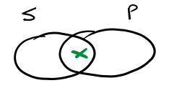**C. Diagram the following statements using Venn Diagrams**

a. Some sculptors are painters

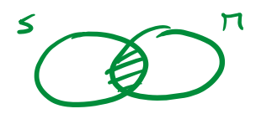

b. No shopkeepers are members

1. 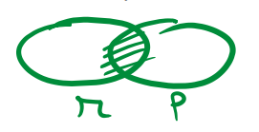No modern paintings are photographic likenesses of their objects.

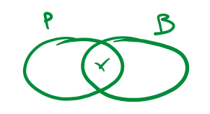

1. Some patients exhibiting all the symptoms of schizophrenia have bipolar disorder



* 1. **Use the Venn diagram to determine if the following immediate inference forms are valid from the Boolean standpoint, conditionally valid from the Aristotelian standpoint, or invalid (reflect on existential import). double check with the square of opposition). double check your results with the square of opposition)**

1. All *A* are *B.*

Therefore, it is false that no *A* are *B.*

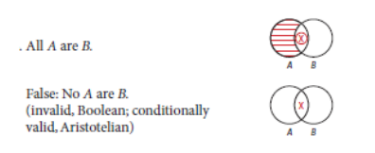

1. It is false that some *A* are *B.*

Therefore, no *A* are *B.*

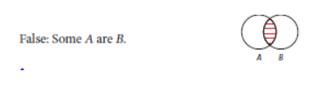

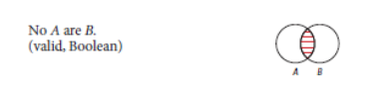

1. No *A* are *B.*

Therefore, some *A* are not *B.*

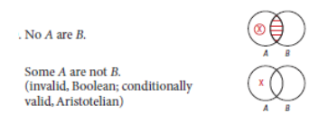

* 1. **Rewrite in standard categorical propositions, individuate subject, predicate, copula and quantifiers. Say which term gets distributed, if any**

1. Any television show that depicts violence incites violence.

**All tv shows that depict violence are tv shows that incite violence.**

**A statement**

2. Manipulators do not make good friends.

**No manipulators are good friends**

**E statement**

3. None but pirate ships fly the Jolly Roger.

**All ships that fly the Jolly Roger are pirate ships.**

**A statement**

4. A man is a bachelor only if he is unmarried.

**All bachelors are unmarried men.**

**A statement**

5. No shellfish except oysters make pearls.

**All shellfish that make pearls are oysters.**

**A statement**

6. Shows that Martin Short are in are always peculiar.

**All shows that Martin Short is in are peculiar shows.**

**A statement**

**F. what logic form?**

a. If I am Miley Cyrus, I am crazy.”

and

“I am not crazy.”

Then there is no way in hell I am Miley Cyrus.

**ANSWER: MODUS TOLLENS**

B. If I am in Tatarstan, I am in Russia.”

and

“I am in Tatarstan.”

Then it must be true that I am in Russia.

**ANSWER: MODUS PONENS**

C. I will choose soup or I will choose salad.

I will not choose soup.

Therefore, I will choose salad.

**ANSWER: DISJUNCTIVE SYLLOGISM**

**LAB SESSIONS – PHIL 1 – WEEK 6**

**EXERCISES**

1. **Answer the Following open question to the best of your possibility. Limit ½ page A4**
2. Summarise the main things you remember about Stoic philosophy
3. Describe the similarities between Stoic logic and propositional logic
4. Who was Leibniz?
5. Describe the main logical operators used in propositional logic, their function and how they are graphically represented
6. Describe the difference between a necessary and sufficient condition. Use an example (not taken from the slides) to illustrate this distinction
7. Describe what is an antecedent and a consequent in propositions. Give 5 examples
8. **Symbolize the following statements and explain/justify the use of the logical operator you chose**
9. Iran raises the price of oil but Libya does not raise the price of oil

5. Iran and Libya both do not raise the price of oil.

10. It is not the case that either Egypt’s food shortage worsens or Jordan requests more U.S. aid

15. Iran won’t raise the price of oil unless Libya does so.

20. Either Iran raises the price of oil and Egypt’s food shortage worsens, or it is not the case both that Jordan requests more U.S. aid and that Saudi Arabia buys five hundred more warplanes

25. Libya raises the price of oil and Egypt’s food shortage worsens; and, Saudi Arabia buys five hundred more warplanes and Jordan requests more U.S. aid.



1. **Symbolize the following statements and explain/justify the use of the logical operator you chose (continue practising)**
2. If Argentina mobilizes, then if Brazil protests to the UN, then Chile will

call for a meeting of all the Latin American states

5. If either Argentina mobilizes or Brazil protests to the UN, then Chile will call for a meeting of all the Latin American states

10. It is not the case that if Argentina mobilizes, then both Brazil will protest to the UN, and Chile will call for a meeting of all the Latin American states.

15. Brazil will protest to the UN only if either Argentina mobilizes or Chile calls for a meeting of all the Latin American states

20. Unless Chile calls for a meeting of all the Latin American states, Brazil will protest to the UN

25. If neither Chile nor the Dominican Republic calls for a meeting of all the Latin American states, then Brazil will not protest to the UN unless Argentina mobilizes





1. **Write down the logical forms for the following syllogisms: i.modus ponens, ii. modus tollens, iii. affirming the consequent, iv. denying the antecedent, v. disjunctive syllogism *both valid and invalid form*. Then give at least two examples for each of these logical forms**

Answers: can be obtained by looking at the weekly slides

**PHIL 1 WEEK 7**

**EXERCISES**

1. **Identify the main operator in the following propositions**

∼(*A*⋁*M*)∼(*C*⊃*E*)

∼(*K* ∼*O*) ≡ ∼(*R* ⋁ ∼*B*)

∼[(*S*⋁*L*)*M*]⊃(*C*⋁*N*)

∼[(*X*⋁*T*)(*N*⋁*F*)]⋁(*K*⊃*L*)

*ANSWERS: DOT, TRIPLE BAR, HORSESHOE,WEDGE* **More of the same**



*ANSWERS: HORSESHOE, NEGATION*

1. **Determine the truth values of the following symbolized statements. Let *A*, *B*, and *C* be true and *X*, *Y*, and *Z* be false. Circle your answer.**

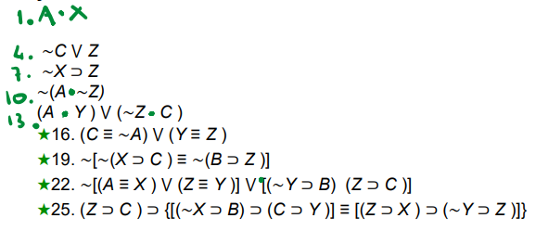 *ANSWERS:*

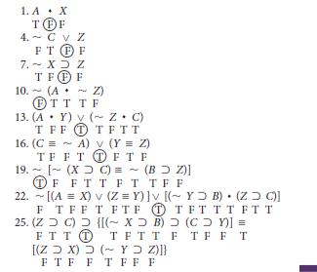

1. **If *A*, *B*, and *C* are true statements and *X*, *Y*, and *Z* are false statements, which of the following are true?**

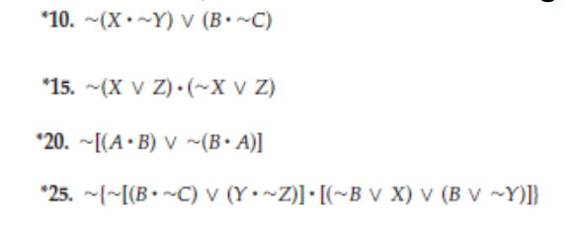

*ANSWER: True, True, False, False.*

1. **COMPUTE**



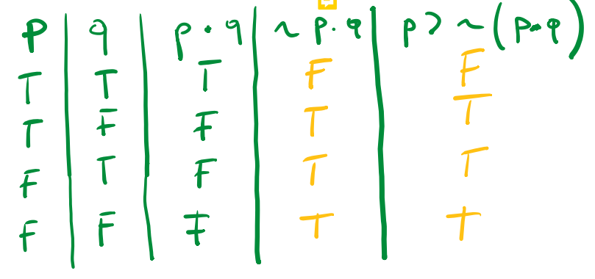

1. **COMPUTE**



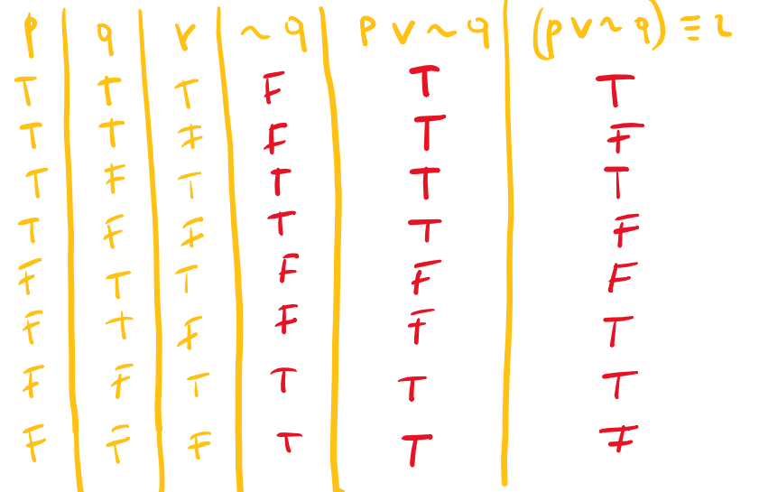

**F. TRANSLATE THE FOLLOWING STATEMENTS INTO PROPOSITIONAL LOGIC**

1. In order to become a PHYSICIAN, it is necessary to RECEIVE an M.D. and do an INTERNSHIP.
2. In order to PASS, it is both necessary and sufficient to average at least FIFTY.
3. Getting a HUNDRED on every exam is sufficient, but not necessary, for ACING intro logic.
4. TAKING all the exams is necessary, but not sufficient, for ACING intro logic.
5. In order to get into MEDICAL school, it is necessary but not sufficient to have GOOD grades and take the ADMISSIONS exam.
6. In order to be a BACHELOR it is both necessary and sufficient to be ELIGIBLE but not MARRIED.
7. In order to be ARRESTED, it is sufficient but not necessary to COMMIT a crime and GET caught.
8. If it is RAINING, I will play BASKETBALL; otherwise, I will go

JOGGING.

1. If both JAY and KAY are home this weekend, we will go to the BEACH; otherwise, we will STAY home.
2. JONES will win the championship unless he gets INJURED, in which case SMITH will win

